eBlessings International Daily Devotional Archives
enrich, inspire, encourage, bless, and empower spiritual warriors for end-time battles
prepared with the guidance of the Holy Spirit for spiritual growth and victory!
Devotionals Designed to Empower and Grow Our Spirits

JULY 2008 JULY 2008 JULY 2008
Visit DOT, and WOW Empowerment Series,
plus Prophecy, Spiritual Keys & Lessons, IA, PP and more...
Each One! Bless One!
You Make a Difference!

* * * * *

We stop the Power of Death with our tongues. So we have power over Death (over him, over it) through the Life, Crucifixion, and Resurrection of Jesus, Yeshua, (MMNL) and through our choices.

“I will ransom them from the power of the grave; I will redeem them from death: O death, I will be thy plagues; O grave, I will be thy destruction: repentance shall be hid from mine eyes.”
HOSEA 13:14 (KJV)

DEATH – 3. Please see Death -1, Wednesday, 2 July; Death -2, Sunday, 6 July 2008. Let us take a look at “death.” Matter (hear: Death) is neither created nor destroyed. The Power of Death was placed in the tongue. The Power of Death “is” in the “action” of the tongue… (A giant key ) “Death and life are in the power of the tongue: and they that love it shall eat the fruit thereof.” Proverb 18:21 (KJ) We stop the Power of Death with our tongues. So we have power over Death (over him, over it) through the Life, Crucifixion, and Resurrection of Jesus, Yeshua, (MMNL) and through our choices.

When Jesus ( Immanuel: God with us) died on the Cross, He was transformed… “…All power is given unto me in heaven and in earth.” Matthew 28:18 (KJ) The physical death of Jesus manifested God’s Victory throughout His Creation by Jesus (MMNL) living in a “sinless” human existence with limited Heavenly, supernatural intervention. This is a giant key.

The Angels could not keep Jesus from dashing His foot on a stone (hear: interfere) (Matthew 4:6; Luke 4:11) and therefore Jesus (MMNL) had to do it (His mission) –on His own –in the flesh —using the same elements in His “Flesh Vessel” as is available to us today in our bodies (when we utilize the mind of Christ). (What is “Christ Mind”? Love the LORD with all your heart, mind, strength, body AND love your neighbor. (A giant key)) If Jesus can (or could) do it, so can you and I; if we only believe and try. (Mark 9:23; Mark 11:23-24)

Immanuel (Jesus) went to hell and got the keys to hell and death; this means He had (has) authority over “hell” and “death.” From the perspective of anthropomorphic personifications, Death thought that Jesus was going to go like the rest of the people (humans) before Him. Death could only hope that Jesus would be subject to him, but he knew deep in his heart what was to come. (TO BE CONTINUED…) Death – 5.

OUR RIGHTEOUSNESS IS NOT OUR OWN
CHRIST = OUR RIGHTEOUSNESS

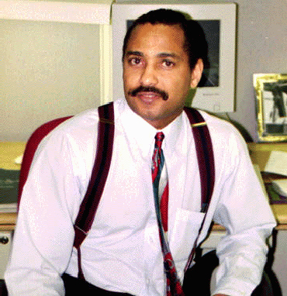
James Anthony Allen, Evangelist
eBlessings Founder
Stone Mountain, Georgia, USA, North America
Email: eblessings@gmail.com

