AQG

A Quick Glimpse

Into
Three-Time Millionaire

DR. AC BROWN’S

WEALTH BUILDING SYSTEM

Including the

P.A.U.S.E. ®
(Practical Application and Use of the Scriptures Everyday)

Wealth Building System

THIS IS A Benefit TO YOU

(Think of AQG® as a start-up like Amway or Avon)

eBlessings
presents

Dr. AC Brown’s

Books * Seminars * Media
Benefits

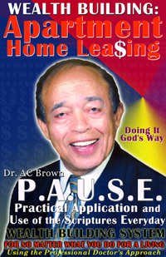

Doing It God’s Way®

(770) 498-7927 (after 9 pm)

(404) 731-1305 (anytime)
AQG, A Quick Glimpse® into Wealth Building incorporates AC Brown’s “Pathway to Success,” a plethora of business acumen, powerful use of Scripture, and the eBlessings’ P.A.U.S.E., Practical Applications and Use of the Scriptures Everyday which is a product of discerning AC Brown’s lifetime track record of accomplishment.

AC has built, owned, and managed sub-divisions and apartment home communities in Greensboro, North Carolina and Atlanta, Georgia; selling 15-20 houses a month in Atlanta when the interest rate was at 17%.

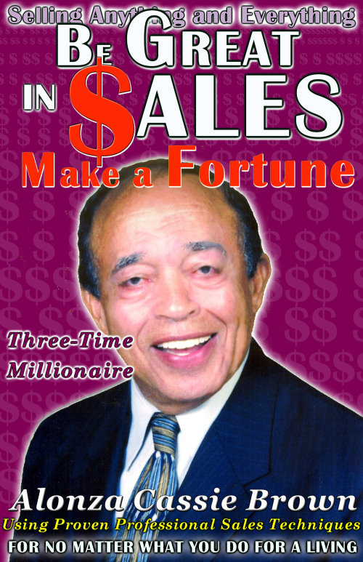

The AQG® Wealth Building System teaches selling in four different markets: General Selling, Real Estate, the Automobile Industry, and Apartment Home Communities in a five-book series. This incredible benefit is represented in four categories. Think of AQG® as a start-up like Amway or Avon; an opportunity, which is really noteworthy and impressive to the astute business person.

BENEFITS

- Books
- Seminars
- Multiple Media Experience
- Multi-Level Marketing

BOOKS

AC Brown in a three-time millionaire who has accumulated a wealth of Wealth Building Secrets, which he wants to share with you and the world.

The “Apartment Leasing” book is the second book in the series, but the first to be published. CreateSpace is the publisher of AC’s training materials. Amazon.com is the distributor of AC’s program of wealth-building.

“Be Great in Sales and Make a Fortune” is the second book in this professional business series.

The third book in the Wealth Building Series is entitled “A Quick Glimpse into AC Brown’s 48 Year Track Record of Accomplishment.” All books are scheduled for 2010 release dates.

SEMINARS

Incorporated in each book will be the P.A.U.S.E. Wealth Building System. This system is a compendium of key scriptures and business tips which AC Brown used during the course of his successful life.

These keys are highlighted as lists at the end of each chapter. Each chapter representing a week. There are sixteen chapters in the book which translates into sixteen weeks of wealth building applications.

When incorporated into seminars using each set of four chapters as the topics for one forty-five minute seminar, this system helps one build wealth in any field of endeavor. There will be four forty-five minute seminars.

Four chapters will be more than enough to support a forty-five minute seminar. In the future, there will be eight seminars instead of the initial four, with a potential for sixteen seminars held simultaneously. The revenue-producing results are staggering.



Remember, there are four markets to which these seminar courses apply. This means that there are four opportunities for simultaneous seminars happening in four different cities. Imagine, one seminar at $225 per seat, with forty seats or more per seminar.

At the seminar, not only do you sell the next upcoming seminars, but you sell the books, CD’s, DVD’s, audiotapes, booklets, T-shirts, mugs, and other merchandise.

One of the many beauties of the seminars is that the seminars are held at resorts and luxury locations so not only can participants enjoy the locations, but you and your team can also. Soon, the initial salespersons and managers will be sitting back and supervising as the Wealth Building System increases the revenue.

MULTIPLE MEDIA EXPERIENCE

AC anticipates high volume selling of his CD’s, audio books, DVD’s, and audiotapes where he imparts invaluable expertise to help stimulate one’s sales potential and invigorate slow sales to everyone’s expected high sales volumes.
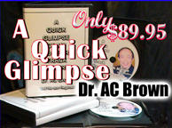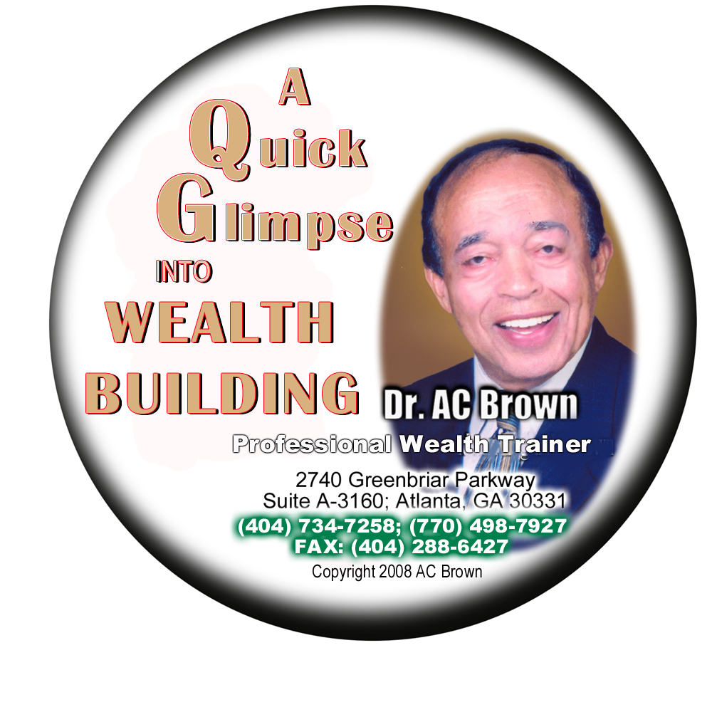

MULTI-LEVEL MARKETING

The true beauty of AQG (A Quick Glimpse) Wealth Building System is how anyone can sell the books, the business acumen, spiritual realities, and the systems, which are incorporated in each book. There are five books in this series. Not only are salespersons a key component of this aspect of this level of benefit, but they will be prepared to lead and manage seminars.

These professionals will take the seminar on the road independently; set it up, manage it, and give the presentation. This team of professionals will be the long-reaching arm of this Multi-Level Marketing aspect of AC Brown’s program of success.

Salespersons get sales percentages of the five different books, and the Pathway to Success; whereas MLM sales persons receive a percentage of the revenue from new managers who they bring on board and from salespersons who they supervise. Everyone is given the opportunity to profit from the benefits AC Brown’s AQG Wealth Building System brings to the market. An opportunity, which brings revenue-producing benefits to the world.

BY THE NUMBERS
(projections)

Books

Payout:
$175,000 annually per book

Seminars
(One day seminar, 40 attendees)

Payout:
$9,000 per day; $225 per attendee minus expenses

Multiple Media Experience

Payout:
$125,000 per year

Multi-Level Marketing

Payout:
$2-3,000,000 the first year increasing for the next five years annually before the bell curve flattens. Yes, that is millions.

SUMMARY

This $250,000 initial investment is payable to eBlessings. This benefit is the financial opportunity for which you have been seeking. The benefits of AC Brown’s record of accomplishment will be imparted by you the investor into individuals, homes, congregations, corporations, regions, and nations.

Be the key benefactor of this great Christian benefit where you sell and distribute God and Christ Jesus to the world; selling God’s Way of making fortunes like Jacob, Abraham and Jesus.

